46 Modeling - Metas
Metas 1
Primitives 2
Visualization 2
Meta Ball Options 2
Resolution 3
Threshold (Influence) 4
Update 4
Meta Structure 5
Technical Details 5
Underlying Structure 5
Editing Metas 6
Meta Shape 7
Stiffness 7
Negative Influence 8
Hiding Elements 9
Deleting Elements 9
Conversion 9
Object Families 9
Examples 10
Hints 11

Metas

Reference
Mode: Object or Edit modes
Menu: Add ‣ Meta

Meta objects are implicit surfaces, meaning that they are not explicitly defined by vertices (as meshes are) or control points (as surfaces are): they exist procedurally. Meta objects are literally mathematical formulas that are calculated on-the-fly by Blender.
A very distinct visual characteristic of metas is that they are fluid mercurial, or clay-like forms that have a “rounded” shape. Furthermore, when two meta objects get close to one another, they begin to interact with one another. They “blend” or “merge”, as water droplets do, especially in zero-g (which, by the way, makes them very handy for modeling streams of water when you don’t want to do a fluid simulation). If they subsequently move away from one another, they restore their original shape.
Each of these is defined by its own underlying mathematical structure (Technical Details), and you can at any time switch between them using the Active Element panel.
Typically Meta objects are used for special effects or as a basis for modeling. For example, you could use a collection of metas to form the initial shape of your model and then convert it to another object type (well, only meshes are available...) for further modeling. Meta objects are also very efficient for ray-tracing.
Note that Meta objects have a slightly different behavior in Object mode.

Primitives
There are five predefined meta “primitives” (or configurations) available in the Add ‣ Meta sub-menu:
Meta Ball
adds a meta with a point underlying structure.
Meta Tube
adds a meta with a line segment underlying structure.
Meta Plane
adds a meta with a planar underlying structure.
Meta Ellipsoid
adds a meta with an ellipsoidal underlying structure.
Meta Cube
adds a meta with a volumetric cubic underlying structure.

Visualization
In Object mode, the calculated mesh is shown, along with a black “selection ring” (becoming pink when selected).
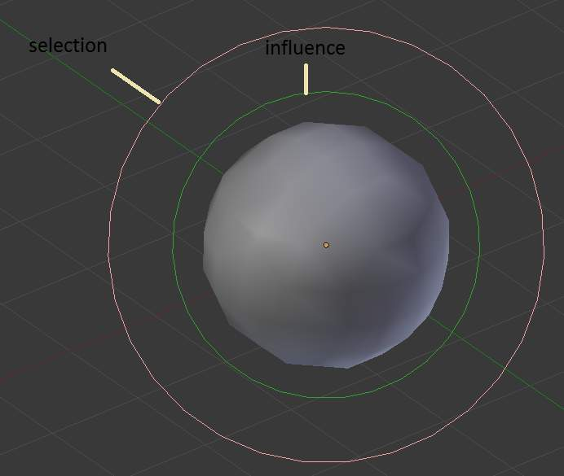
Meta Ball example.
In Edit mode (Meta Ball example), a meta is drawn as a mesh (either shaded or as black wireframe, but without any vertex of course), with two colored circles: a red one for selection (pink when selected), and a green one for a direct control of the meta’s stiffness (light green when active). Note that except for the Scale (S) transformation, having the green circle highlighted is equivalent to having the red one.

Meta Ball Options
All Meta objects in a scene interact with each other. The settings in the MetaBall section apply to all meta objects. In Edit mode, the Active Element panel appears for editing individual meta elements.
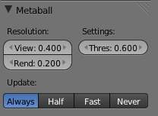  global meta properties. | 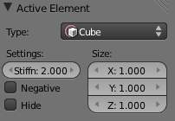  individual meta properties.

Resolution
The Resolution controls the resolution of the resultant mesh as generated by the
Meta
object.
View
The 3D View resolution of the generated mesh. The range is from 0.05 (finest) to 1.0 (coarsest).
Render
The rendered resolution of the generated mesh. The range is from 0.05 (finest) to 1.0 (coarsest).
One way to see the underlying mathematical structure is to lower the Resolution, increase the Threshold and set the Stiffness (see below) a fraction above the Threshold. (Underlying structure) is a (Meta cube) with the above mentioned configuration applied as follows: Resolution of 0.410, Threshold of 5.0 and Stiffness a fraction above at 5.01.
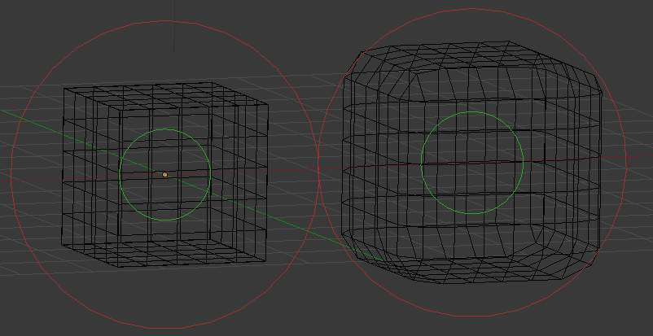
Left: Underlying structure, Right: the shape.
You can clearly see the underlying cubic structure that gives the meta cube its shape.

Threshold (Influence)
Reference
Mode: Object or Edit modes
Panel: MetaBall (Editing context)

Threshold defines how much a meta’s surface “influences” other metas. It controls the field level at which the surface is computed. The setting is global to a group of Meta objects. As the threshold increases, the influence that each meta has on each other increases.
There are two types of influence: positive or negative. The type can be toggled on the Active Element panel while in Edit mode, using the Negative button. You could think of positive as attraction and negative as repulsion of meshes. A negative meta will push away or repel the meshes of positive Meta objects.
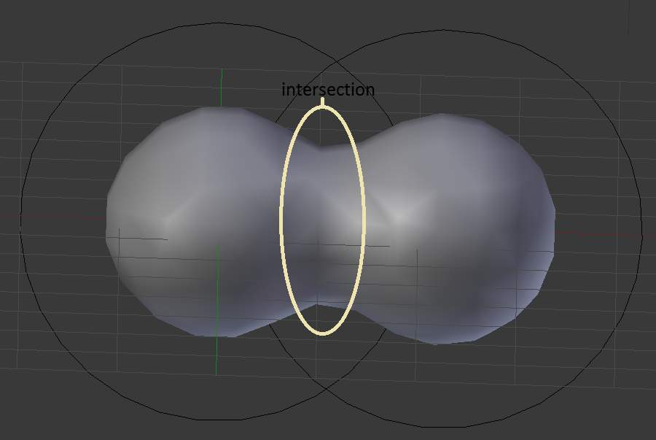
Positive.
A positive influence is defined as an attraction, meaning the meshes will stretch towards each other as the rings of influence intersect. (Positive) shows two meta balls’ rings of influence intersecting with a positive influence.
Notice how the meshes have pulled towards one another. The area circled in white shows the green influence rings intersecting.

Update
While transforming metas (grab/move, scale, etc.), you have four “modes” of visualization, located in the Update buttons group of the MetaBall panel:
Always
fully draw the meta during transformations.
Half Res
During transformations, draw the meta at half its Wiresize resolution.
Fast
Do not show meta mesh during transformations.
Never
Never show meta mesh (not a very recommended option, as the meta is only visible at render time!).
This should help you if you experience difficulties (metas are quite compute-intensive...), but with modern computers, this shouldn’t happen, unless you use many metas, or very high resolutions...

Meta Structure

Technical Details
A more formal definition of a meta object can be given as a directing structure which can be seen as the source of a static field. The field can be either positive or negative and hence the field generated by neighboring directing structures can attract or repel.
The implicit surface is defined as the surface where the 3D field generated by all the directing structures assume a given value. For example a meta ball, whose directing structure is a point, generates an isotropic (i.e. identical in all directions) field around it and the surfaces at constant field value are spheres centered at the directing point.
Meta objects are nothing more than mathematical formulae that perform logical operations on one another (AND, OR), and that can be added and subtracted from each other. This method is also called Constructive Solid Geometry (CSG). Because of its mathematical nature, CSG uses little memory, but requires lots of processing power to compute.

Underlying Structure
Reference
Mode: Edit mode
Panel: MetaBall tools (Editing context), Transform Properties

Bforartistshas five types of metas, each determined by its underlying (or directing) structure. In Edit mode, you can change this structure, either using the relevant buttons in the MetaBall tools panel, or the drop-down list in the Transform Properties panel (N). Depending on the structure, you might have additional parameters, located in both Transform Properties and MetaBall tools panels.
Ball (point, zero-dimensional structure)
This is the simplest meta, without any additional setting. As it is just a point, it generates an isotropic field, yielding a spherical surface (this is why it is called Meta Ball or Ball in Blender).
Tube (straight line, uni-dimensional structure)
This is a meta which surface is generated by the field produced by a straight line of a given length. This gives a cylindrical surface, with rounded closed ends. It has one additional parameter:
dx
The length of the line (and hence of the tube - defaults to 1.0).
Plane (rectangular plane, bi-dimensional structure)
This is a meta which surface is generated by the field produced by a rectangular plane. This gives a parallelepipedal surface, with a fixed thickness, and rounded borders. It has two additional parameters:
dx, dy
The length, width of the rectangle (defaults to 1.0).
Note that by default, the plane is a square.
Elipsoid (ellipsoidal volume, tri-dimensional structure)
This is a meta which surface is generated by the field produced by an ellipsoidal volume. This gives an ellipsoidal surface. It has three additional parameters:
dx, dy, dz
The length, width, height of the ellipsoid (defaults to 1.0).
Note that by default, the volume is a sphere, producing a spherical meta, as the Ball option...
Cube (parallelepipedal volume, tri-dimensional structure)
This is a meta which surface is generated by the field produced by a parallelepipedal volume. This gives a parallelepipedal surface, with rounded edges. As you might have guessed, it has three additional parameters:
dx, dy, dz
The length, width, height of the parallelepiped (defaults to 1.0).
Note that by default, the volume is a cube.
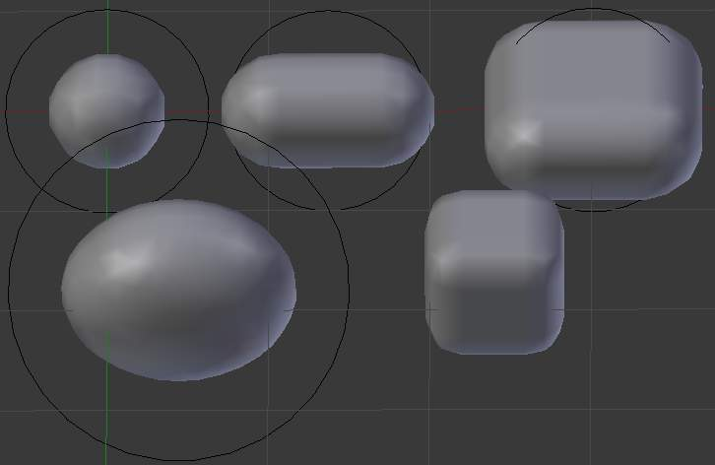
the 5 meta primitives.

Editing Metas

When in Edit mode, the Active Element panel appears. These settings apply only to the selected meta element.
the active element panel.

Meta Shape
The Type menu lets you change the shape of the meta object, as explained above.

Stiffness
Together with Threshold, Stiffness controls the influencing range. While the threshold is common to all metas in the same object (or even the same Object Families), the stiffness is specific to each meta.
Scaling the inner green circle changes the Stiffness value. Stiffness defines how much the meta object is filled. This essentially defines how sensitive a meta is to being affected by other metas. With a low stiffness, the meta will begin to deform from further away. A higher value means the meta needs to be close to another one to begin merging.
When a Meta object comes within “range” of another meta, the two will begin to interact with each other. They don’t necessarily need to intersect, and depending on the Threshold and Stiffness settings, they most likely won’t need to. Stiffness is materialized by the green ring
The range is from 0.0 to 10.0. But to be visible, the Stiffness must be slightly larger than the Threshold value. You can also visually adjust the Stiffness ring by using the RMB to select it and activate Scale mode with S.
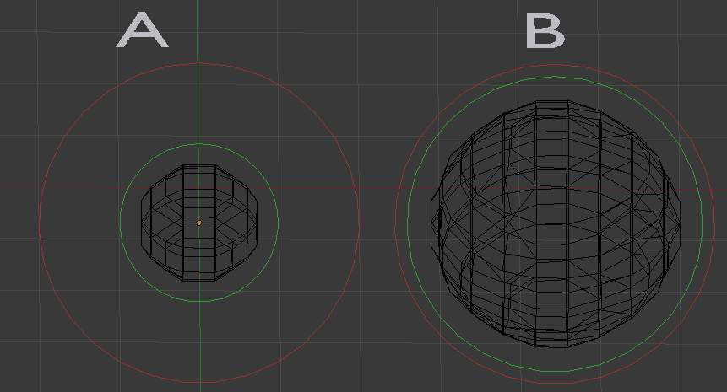
Stiffness.
In (Stiffness), the meta ball labeled A, has a smaller Stiffness value than the one labeled B. As you can see, the green ring radius is different for each of them.

Negative Influence
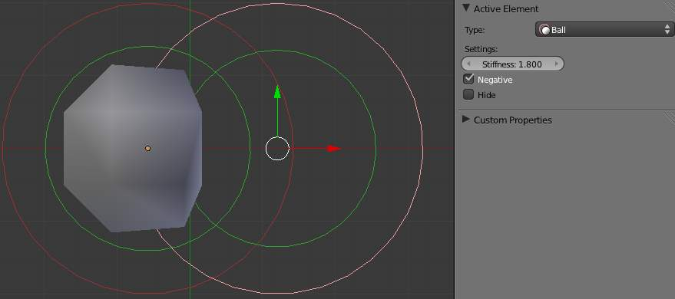
Negative.
The opposite effect of a positive influence would be a negative influence: the objects repel each other. (Negative) shows a meta ball and a meta plane where the first is negative and the second, positive. Notice how the negative meta is not visible: only the surrounding circles appear. This is how Bforartistsindicates that the object is negative.
Moving the sphere to the plane causes the plane’s mesh to “cave in” or collapse inward. If you move the plane away from the sphere, the plane’s mesh will restore itself.
To make a meta negative, just select the meta in edit mode, and check negative in the active element panel.

Hiding Elements
As in Object mode, you can hide the selected meta(s), and then reveal what was hidden. This is very handy for cleaning your views up a bit... Note that the two red and green rings always remain visible in Edit mode, as well as the select circle (in Object mode...).
To hide the current selection, use H, the Hide toggle button in the MetaBall tools, or the Metaball ‣ Hide MetaElems ‣ Hide Selected menu option.
To hide everything but the current selection, press Shift-H or use Metaball ‣ Hide MetaElems ‣ Hide Deselected.
To reveal what was hidden, use Alt-H, or the relevant option in the same Metaball ‣ Hide MetaElems menu. You can also un-toggle the Hide button in the (MetaBall tools panel).

Deleting Elements
There is no Erase menu for metas, just a confirmation pop-up asking you if you want to delete the selected metas. Clear and simple!

Conversion
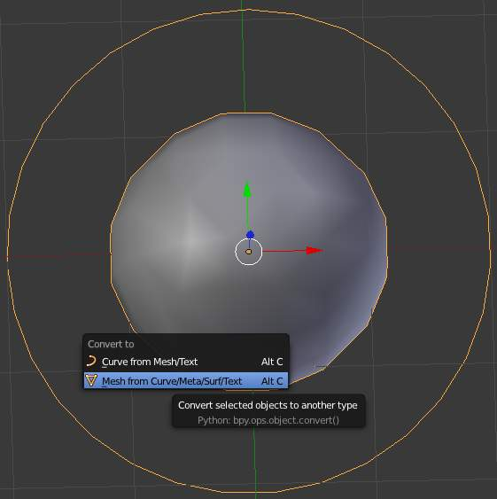
the convert menu
You can only convert metas to meshes, but here you have the option to keep the original Meta object (i.e. create a new Mesh one, instead of a “real” conversion...). Note that the resolution used for the new mesh is the Wiresize one, not the Rendersize one.

Object Families
Meta objects have different behavior in Object mode than other object types - they can be “regrouped” into so-called “families”.
A “family” is a way to regroup several meta objects, producing something very similar to having several metas inside the same object.
A family is defined by the left part of an object’s name (the one before the dot). Remember, an object’s name is the one in the OB field, in most panels, not the MB field, which is the meta data-block’s name... For example, the family part of MetaPlane.001 is MetaPlane. Each meta object in the same “family” is associated with one another as discussed below.
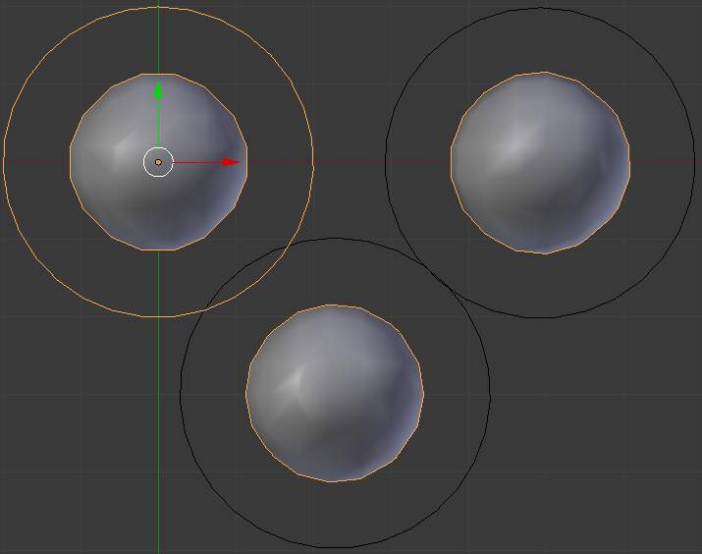
Meta ball base.
Families of metas are controlled by a base Meta object which is identified by an Object name without a right part. For example, if we have five metas called MetaThing ”, MetaThing.001, MetaThing.002, MetaThing.003 and MetaThing.004, the base Meta object would be MetaThing.
The base Meta object determines the basis, the resolution, the threshold, and the transformations. It also has the material and texture area. The base meta is effectively the parent of (or perhaps a better word to use is “the owner of”) the other metas in the group (i.e. it is as if the other metas were “included” or joined into the base one).

Examples
(Meta ball base) shows the base meta labeled B. The other two Meta objects are children. Children’s selection rings are always black, while the group’s mesh is orange. Because the metas are grouped, they form a unified mesh which can always be selected by selecting the mesh of any meta in the group. For example, in the example (Meta ball base), only the lower sphere (the parent) has been selected, and you see that both the parent’s mesh and all of the children’s meshes are now highlighted.
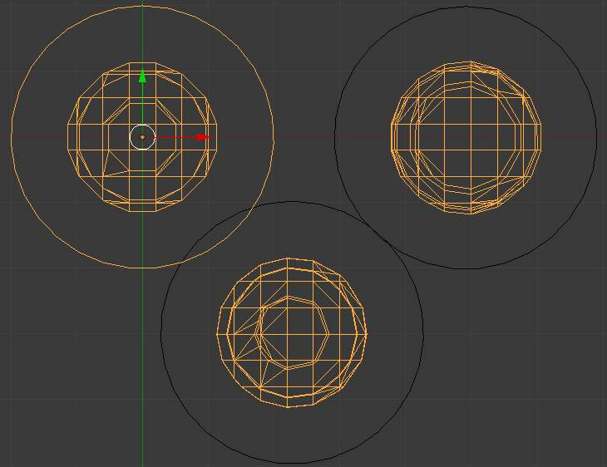
Scaling the “base”.
The base Meta object controls the polygonalization (mesh structure) for the group, and as such, also controls the polygonalization for the children (non-base) metas. If we transform the base meta, the children’s polygonalization changes. However, if we transform the children, the polygonalization remains unchanged.

Hints
This discussion of “polygonization” doesn’t mean that the various meshes don’t deform towards or away from each other (meta objects always influence one another in the usual way, whether or not they are members of the same family). Rather, it means that the underlying mesh structure changes only when the base object transforms. For example, if you scale the base, the children’s mesh structure changes. In (Scaling the “base”), the base has been scaled down, which has the effect of scaling the mesh structure of each of the children. As you can see, the children’s mesh resolution has increased, while the base decreased. The children did not change size!

